SPRING INTEGRATION (MATERIALE PER SLIDES)

Riferimento a reference ufficiali:

Spring integration: Intro

It extends the Spring programming model into the messaging domain and builds upon Spring's existing enterprise integration support to provide an even higher level of abstraction.
It supports message-driven architectures where inversion of control applies to runtime concerns, such as when certain business logic should execute and where the response should be sent.
It supports routing and transformation of messages so that different transports and different data formats can be integrated without impacting testability.
In other words, the messaging and integration concerns are handled by the framework, so business components are further isolated from the infrastructure and developers are relieved of complex integration responsibilities.
As an extension of the Spring programming model, Spring Integration provides a wide variety of configuration options including
- annotations,
- XML with namespace support,
- XML with generic "bean" elements,
- direct usage of the underlying API.

That API is based upon well-defined strategy interfaces and non-invasive, delegating adapters.
Spring Integration's design is inspired by the recognition of a strong affinity between common patterns within Spring and the well-known Enterprise Integration Patterns as described in the book of the same name by Gregor Hohpe and Bobby Woolf (Addison Wesley, 2004).

Obiettivi Spring Integration:
Spring Integration is motivated by the following goals:
- Provide a simple model for implementing complex enterprise integration solutions.
- Facilitate asynchronous, message-driven behavior within a Spring-based application.
- Promote intuitive, incremental adoption for existing Spring users.
Spring Integration is guided by the following principles:
- Components should be loosely coupled for modularity and testability.
- The framework should enforce separation of concerns between business logic and integration logic.
- Extension points should be abstract in nature but within well-defined boundaries to promote reuse and portability.

Spring tradizionale vs Spring Integration:
layered architecture facilitates separation of concerns,
and interface-based contracts between layers promote loose coupling.
Spring Integration rafforza la separazione di responsabilità introducendo un nuovo layer che si occupa di Integration tra diversi sistemi, rendendo questa problematica trasparente rispetto agli altri componenti dell’applicazione.

Concetti generali:

Message-driven architectures add a horizontal perspective, yet these same goals are still relevant.
Just as "layered architecture" is an extremely generic and abstract paradigm, messaging systems typically follow the similarly abstract "pipes-and-filters" model.
The "filters" represent any component that is capable of producing and/or consuming messages, and
the "pipes" transport the messages between filters so that the components themselves remain loosely-coupled.

It is important to note that these two high-level paradigms are not mutually exclusive.
The underlying messaging infrastructure that supports the "pipes" should still be encapsulated in a layer whose contracts are defined as interfaces.
Likewise, the "filters" themselves would typically be managed within a layer that is logically above the application's service layer, interacting with those services through interfaces much in the same way that a web-tier would

Message
In Spring Integration, a Message is a generic wrapper for any Java object combined with metadata used by the framework while handling that object.
It consists of a payload and headers.
The payload can be of any type and the headers hold commonly required information such as id, timestamp, expiration, and return address.
Headers are also used for passing values to and from connected transports.

Image Message

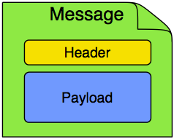

Example
For example, when creating a Message from a received File, the file name may be stored in a header to be accessed by downstream components.
Likewise, if a Message's content is ultimately going to be sent by an outbound Mail adapter, the various properties (to, from, cc, subject, etc.) may be configured as Message header values by an upstream component.
Developers can also store any arbitrary key-value pairs in the headers

Message Channel
A Message Channel represents the "pipe" of a pipes-and-filters architecture.
Producers send Messages to a channel, and consumers receive Messages from a channel.
The Message Channel therefore decouples the messaging components, and also provides a convenient point for interception and monitoring of Messages.
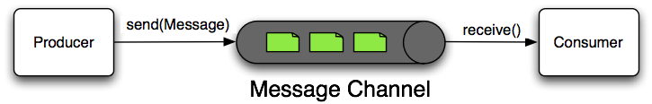

Modelli di comunicazione
A Message Channel may follow either Point-to-Point or Publish/Subscribe semantics.
With a Point-to-Point channel, at most one consumer can receive each Message sent to the channel.
Publish/Subscribe channels, on the other hand, will attempt to broadcast each Message to all of its subscribers. Spring Integration supports both of these.
Whereas "Point-to-Point" and "Publish/Subscribe" define the two options for how many consumers will ultimately receive each Message, there is another important consideration: should the channel buffer messages?
In Spring Integration, Pollable Channels are capable of buffering Messages within a queue.

The advantage of buffering is that it allows for throttling the inbound Messages and thereby prevents overloading a consumer.
However, as the name suggests, this also adds some complexity, since a consumer can only receive the Messages from such a channel if a poller is configured.
On the other hand, a consumer connected to a Subscribable Channel is simply Message-driven.

channel implementations

Message Endpoint
One of the primary goals of Spring Integration is to simplify the development of enterprise integration solutions through inversion of control.
This means that you should not have to implement consumers and producers directly, and you should not even have to build Messages and invoke send or receive operations on a Message Channel.
Instead, you should be able to focus on your specific domain model with an implementation based on plain Objects.
Then, by providing declarative configuration, you can "connect" your domain-specific code to the messaging infrastructure provided by Spring Integration.
The components responsible for these connections are Message Endpoints.
This does not mean that you will necessarily connect your existing application code directly. Any real-world enterprise integration solution will require some amount of code focused upon integration concerns such as routing and transformation.
The important thing is to achieve separation of concerns between such integration logic and business logic.
In other words, as with the Model-View-Controller paradigm for web applications, the goal should be to provide a thin but dedicated layer that translates inbound requests into service layer invocations, and then translates service layer return values into outbound replies.

1.4 Message Endpoints
A Message Endpoint represents the "filter" of a pipes-and-filters architecture.
As mentioned above, the endpoint's primary role is to connect application code to the messaging framework and to do so in a non-invasive manner.
In other words, the application code should ideally have no awareness of the Message objects or the Message Channels.
This is similar to the role of a Controller in the MVC paradigm. Just as a Controller handles HTTP requests, the Message Endpoint handles Messages. Just as Controllers are mapped to URL patterns, Message Endpoints are mapped to Message Channels. The goal is the same in both cases: isolate application code from the infrastructure.

Tipi di MessageEndPoint

Transformer
A Message Transformer is responsible for converting a Message's content or structure and returning the modified Message.
Probably the most common type of transformer is one that converts the payload of the Message from one format to another (e.g. from XML Document to java.lang.String). Similarly, a transformer may be used to add, remove, or modify the Message's header values.

Filter
A Message Filter determines whether a Message should be passed to an output channel at all.
This simply requires a boolean test method that may check for a particular payload content type, a property value, the presence of a header, etc.
If the Message is accepted, it is sent to the output channel, but if not it will be dropped (or for a more severe implementation, an Exception could be thrown).
Message Filters are often used in conjunction with a Publish Subscribe channel, where multiple consumers may receive the same Message and use the filter to narrow down the set of Messages to be processed based on some criteria.

Note
Be careful not to confuse the generic use of "filter" within the Pipes-and-Filters architectural pattern with this specific endpoint type that selectively narrows down the Messages flowing between two channels. The Pipes-and-Filters concept of "filter" matches more closely with Spring Integration's Message Endpoint: any component that can be connected to Message Channel(s) in order to send and/or receive Messages.

Router
A Message Router is responsible for deciding what channel or channels should receive the Message next (if any).
Typically the decision is based upon the Message's content and/or metadata available in the Message Headers.
A Message Router is often used as a dynamic alternative to a statically configured output channel on a Service Activator or other endpoint capable of sending reply Messages. Likewise, a Message Router provides a proactive alternative to the reactive Message Filters used by multiple subscribers as described above.
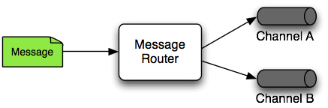

Splitter
A Splitter is another type of Message Endpoint whose responsibility is to accept a Message from its input channel, split that Message into multiple Messages, and then send each of those to its output channel.
This is typically used for dividing a "composite" payload object into a group of Messages containing the sub-divided payloads.

Aggregator
Basically a mirror-image of the Splitter, the Aggregator is a type of Message Endpoint that receives multiple Messages and combines them into a single Message.
In fact, Aggregators are often downstream consumers in a pipeline that includes a Splitter.
Technically, the Aggregator is more complex than a Splitter, because it is required to maintain state (the Messages to-be-aggregated), to decide when the complete group of Messages is available, and to timeout if necessary.
Furthermore, in case of a timeout, the Aggregator needs to know whether to send the partial results or to discard them to a separate channel. Spring Integration provides a CompletionStrategy as well as configurable settings for timeout, whether to send partial results upon timeout, and the discard channel.

Service Activator (mappa message in e out con servizio.metodo in e out)
A Service Activator is a generic endpoint for connecting a service instance to the messaging system.
The input Message Channel must be configured, and if the service method to be invoked is capable of returning a value, an output Message Channel may also be provided.
Note
The output channel is optional, since each Message may also provide its own 'Return Address' header. This same rule applies for all consumer endpoints.
The Service Activator invokes an operation on some service object to process the request Message, extracting the request Message's payload and converting if necessary (if the method does not expect a Message-typed parameter). Whenever the service object's method returns a value, that return value will likewise be converted to a reply Message if necessary (if it's not already a Message). That reply Message is sent to the output channel. If no output channel has been configured, then the reply will be sent to the channel specified in the Message's "return address" if available.
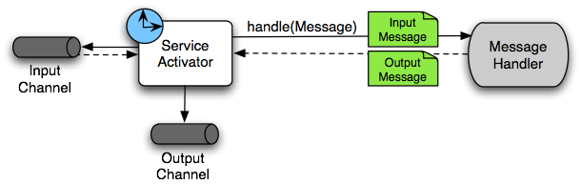
A request-reply "Service Activator" endpoint connects a target object's method to input and output Message Channels.

Channel Adapter
A Channel Adapter is an endpoint that connects a Message Channel to some other system or transport.
Channel Adapters may be either inbound or outbound.
Typically, the Channel Adapter will do some mapping between the Message and whatever object or resource is received-from or sent-to the other system (File, HTTP Request, JMS Message, etc).
Depending on the transport, the Channel Adapter may also populate or extract Message header values. Spring Integration provides a number of Channel Adapters.
Inbound Channel Adapter
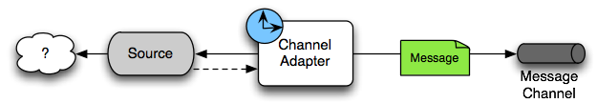
An inbound "Channel Adapter" endpoint connects a source system to a MessageChannel.

Outbound Channel Adapter
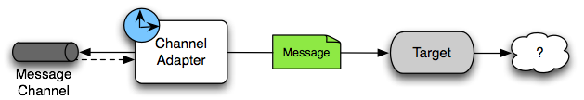
An outbound "Channel Adapter" endpoint connects a MessageChannel to a target system.
API:

